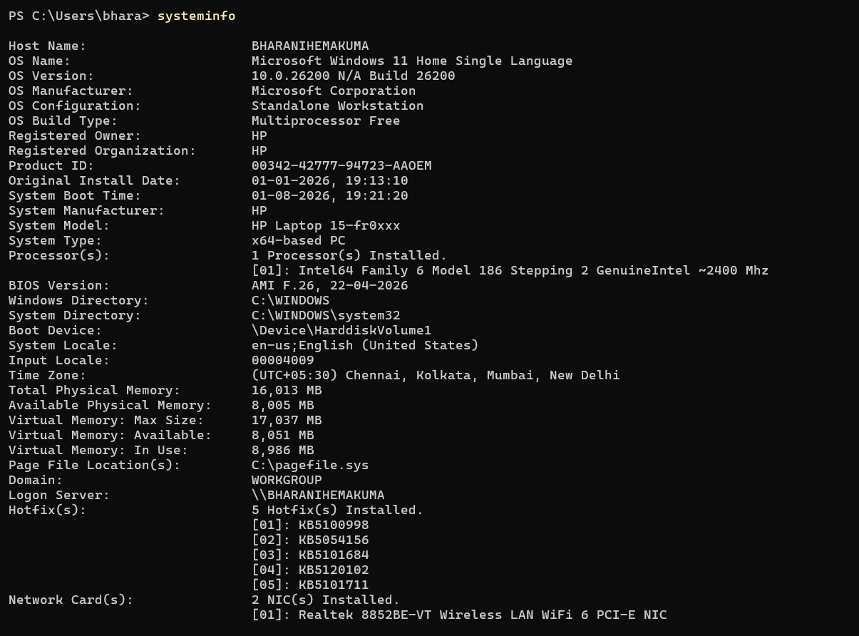
1.SYSTEMINFO
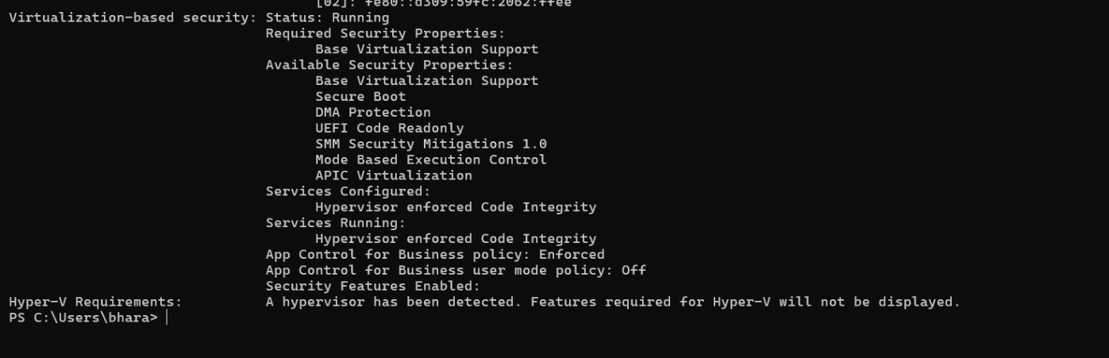

2.HOSTNAME
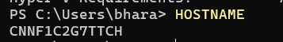

3.WHOAMI/ALL
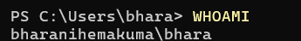

4. NET USER
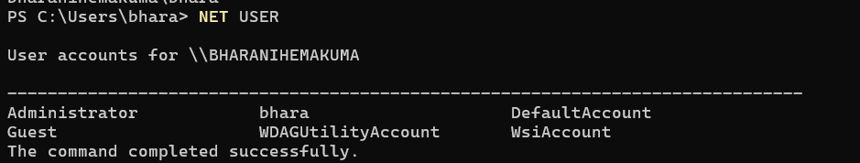

5. NET LOCAL GROUP ADMINSTRATORS
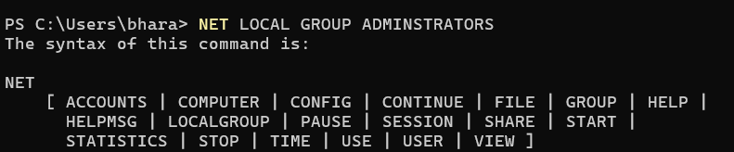
6. IPCONFIG
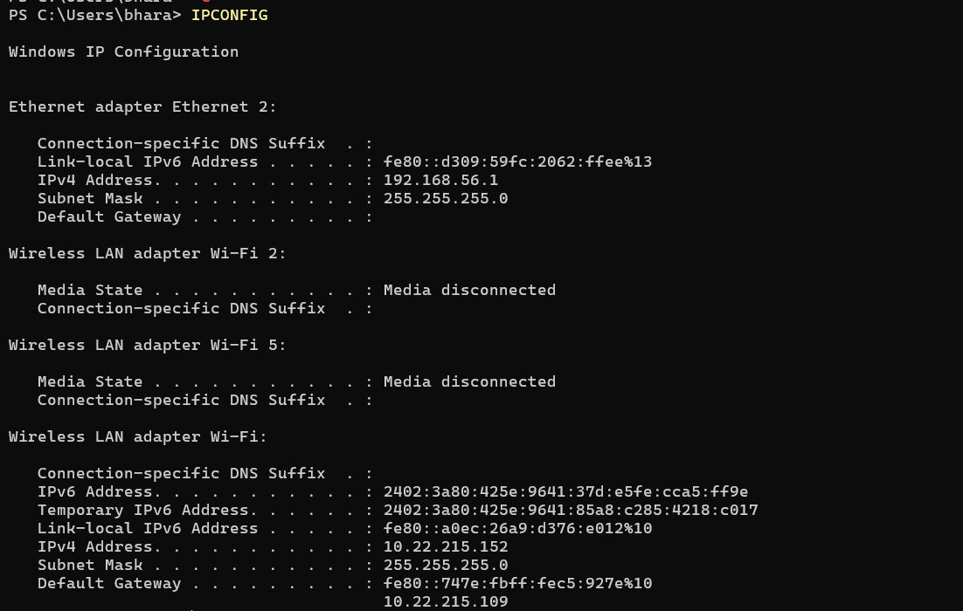
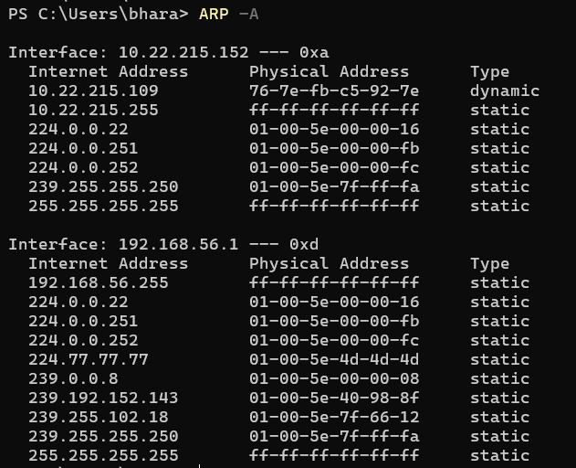
7. ARP -A

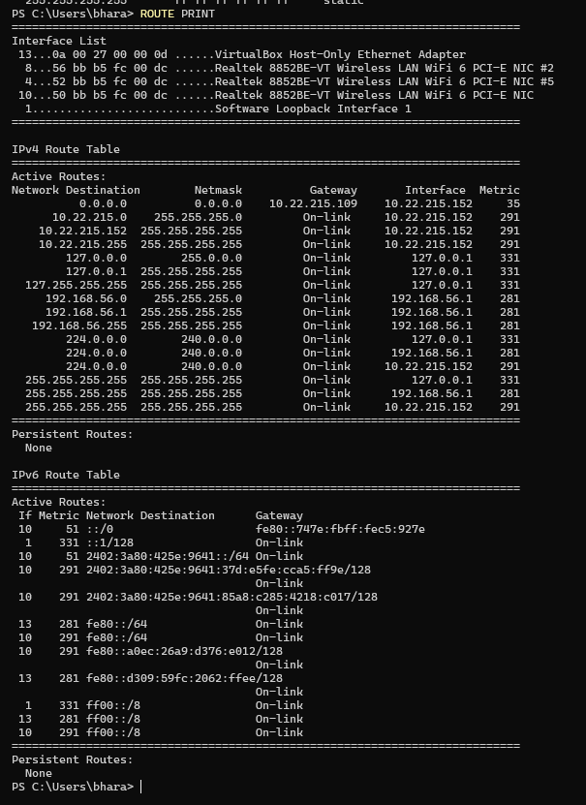
8. ROUTE PRINT

9. NETSTAT -ANO

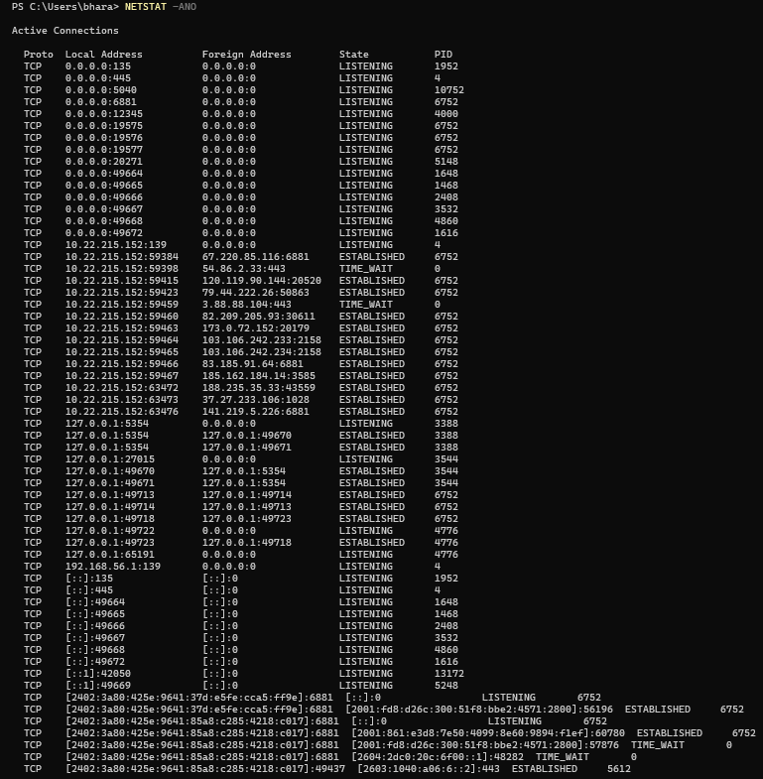
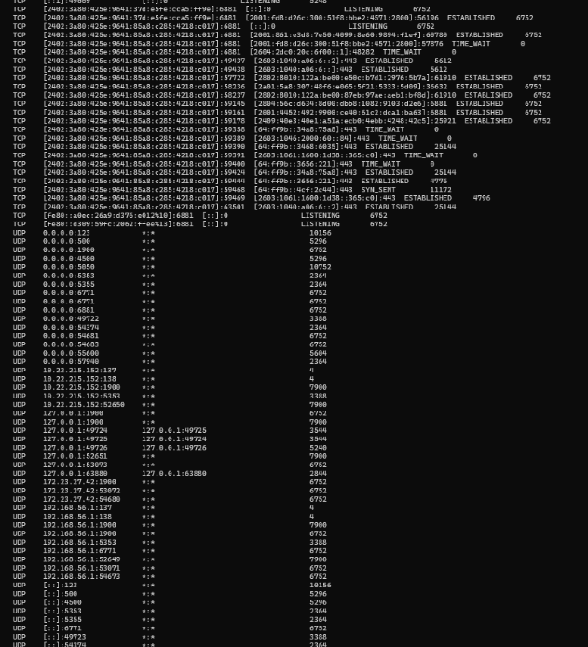
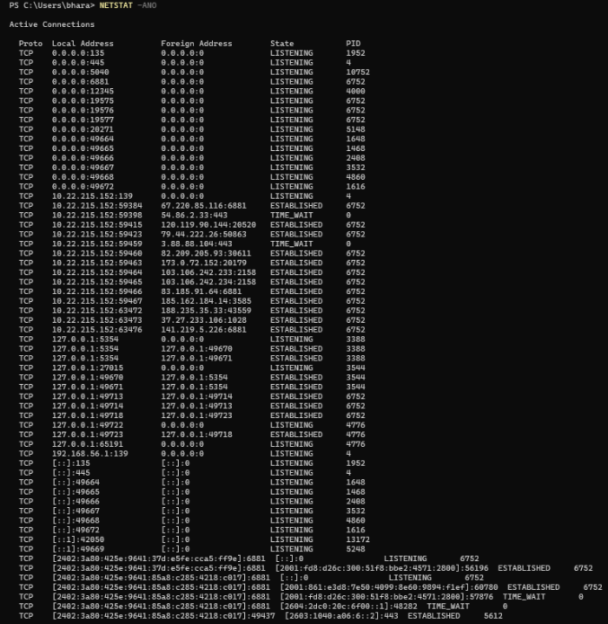

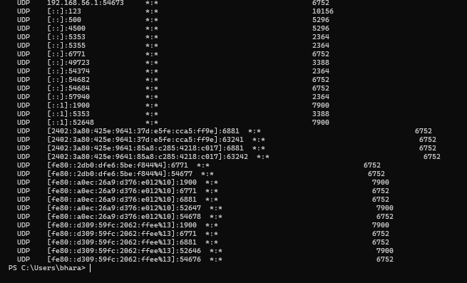


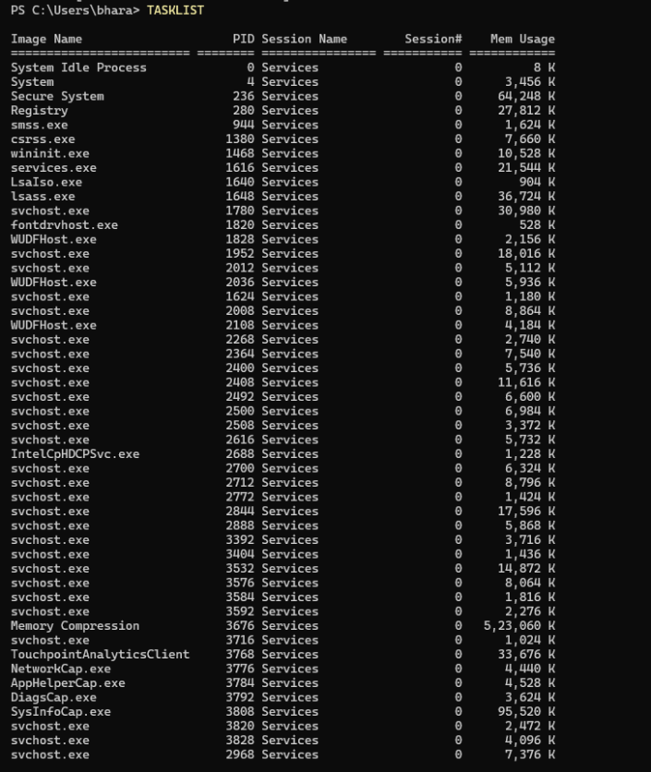
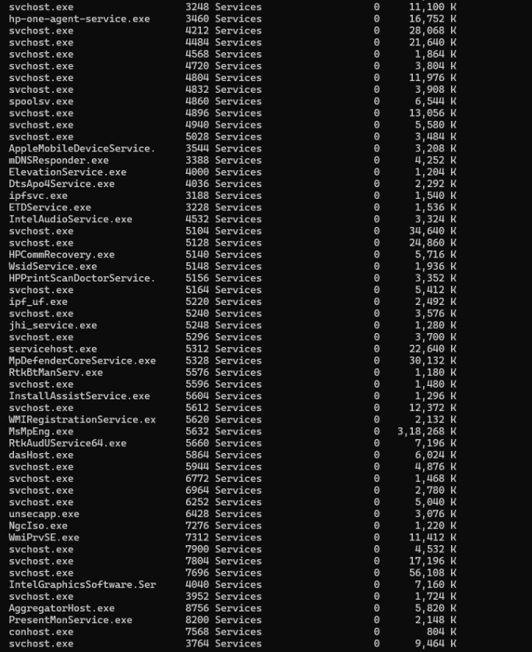
10.TASKLIST

11.SC OUERY
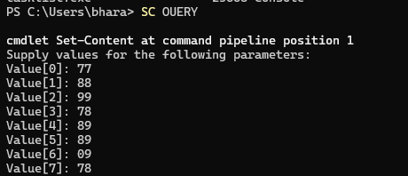
12. NET SHARE
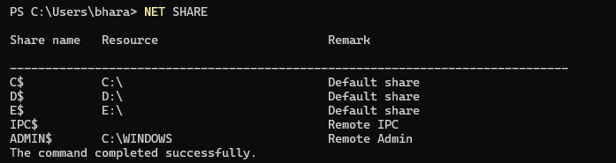

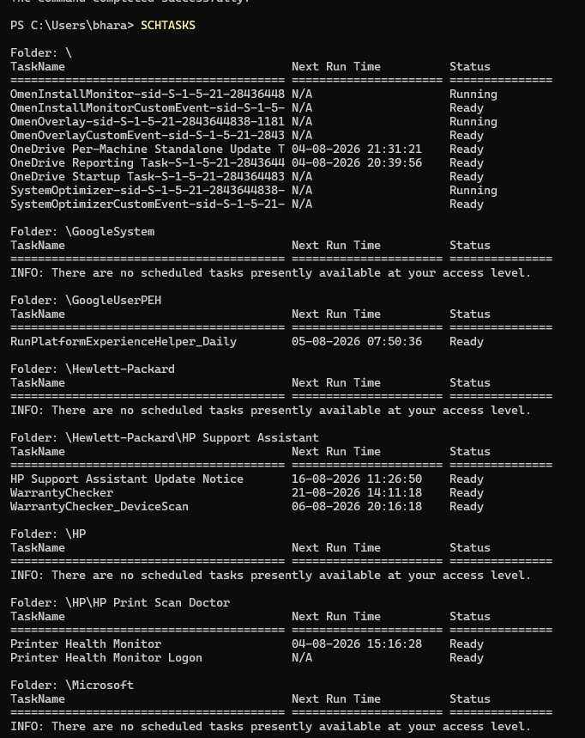
13.SCHTASKS

14. GET -NETADAPTER
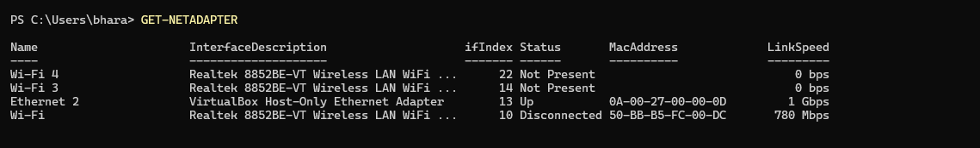

15.GET-PACKAGE
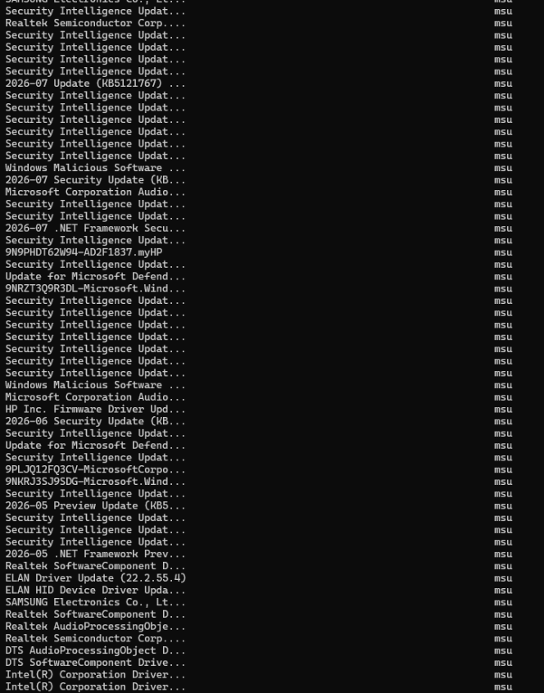
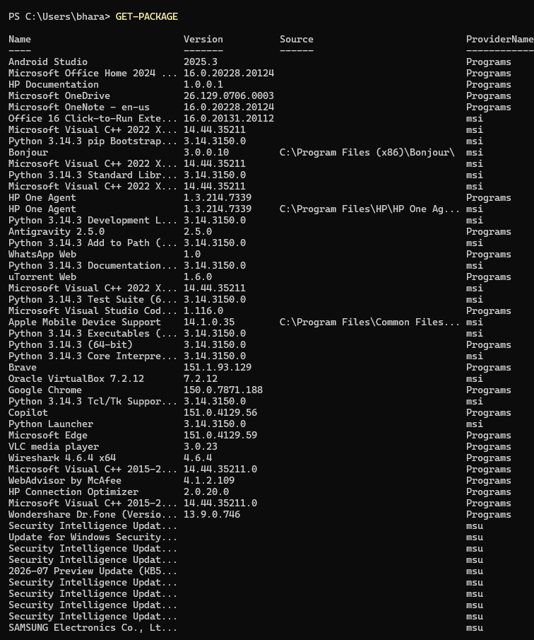
16. GET-ITEMPROPERTY HKLM:\SOFTWARE\MICROSOFT\WINDOWS\CURRENTVERSION\UNINSTALL\* |
>> SELECT-OBJECT DISPLAYNAME, DISPLAYVERSION
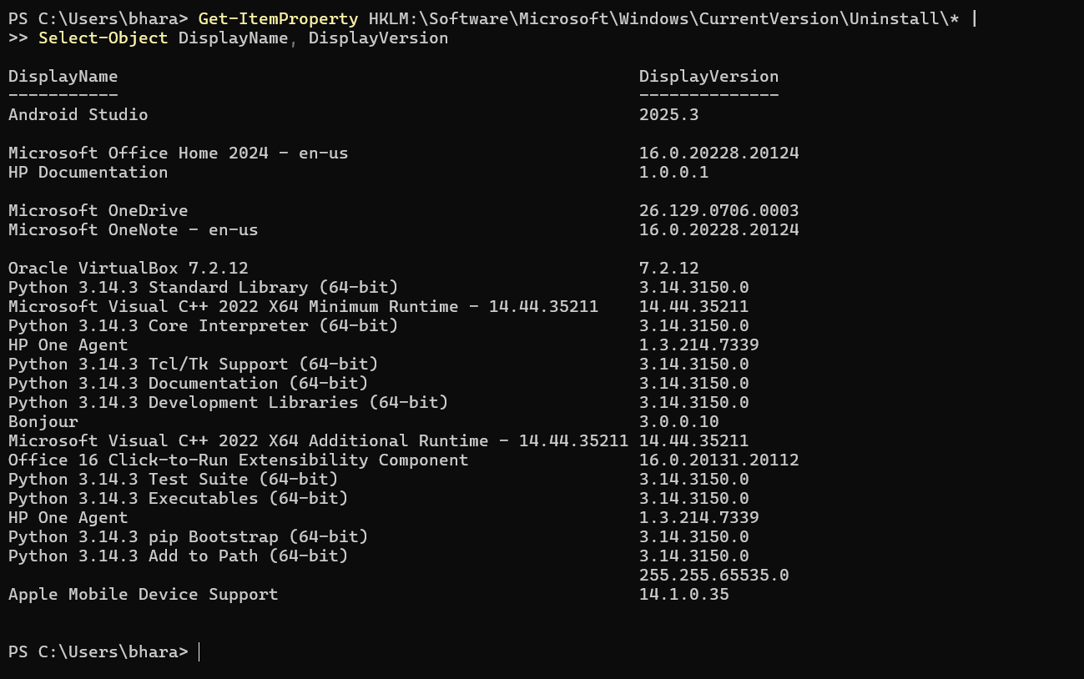

17. RAM (MEMORY) SERIAL NUMBER
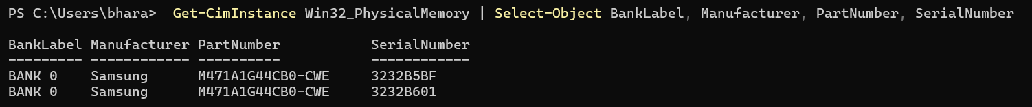
18. SPEAKER (AUDIO DEVICE) INFORMATION
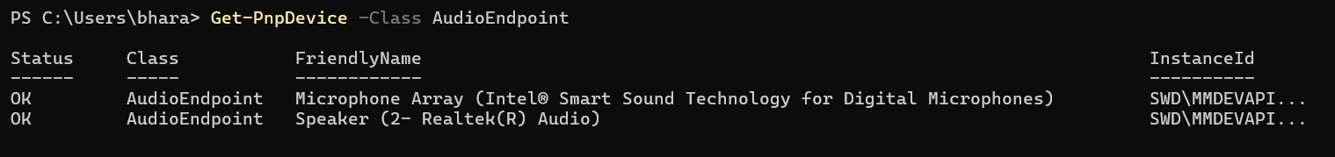
19.FIND THE UNINSTALLED APPS
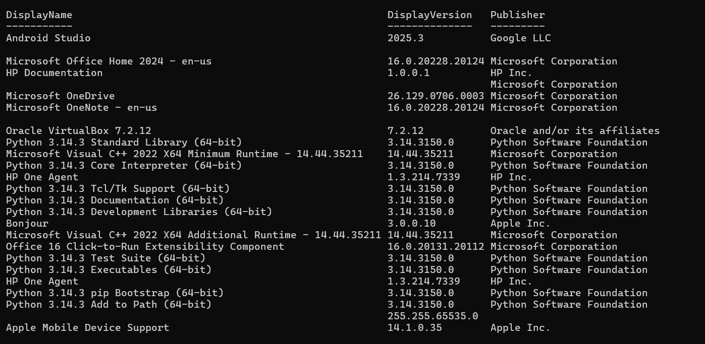
20. DISPLAY CURRENT DATE/TIME
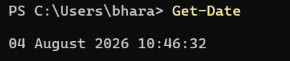
21. SHOW RUNNING PROCESSES
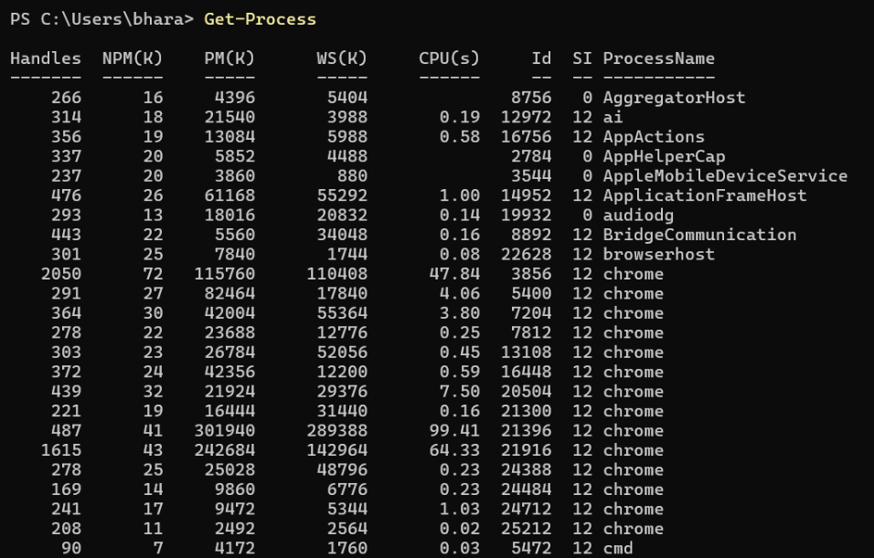

22. DISPLAY INSTALLED SOFTWARE
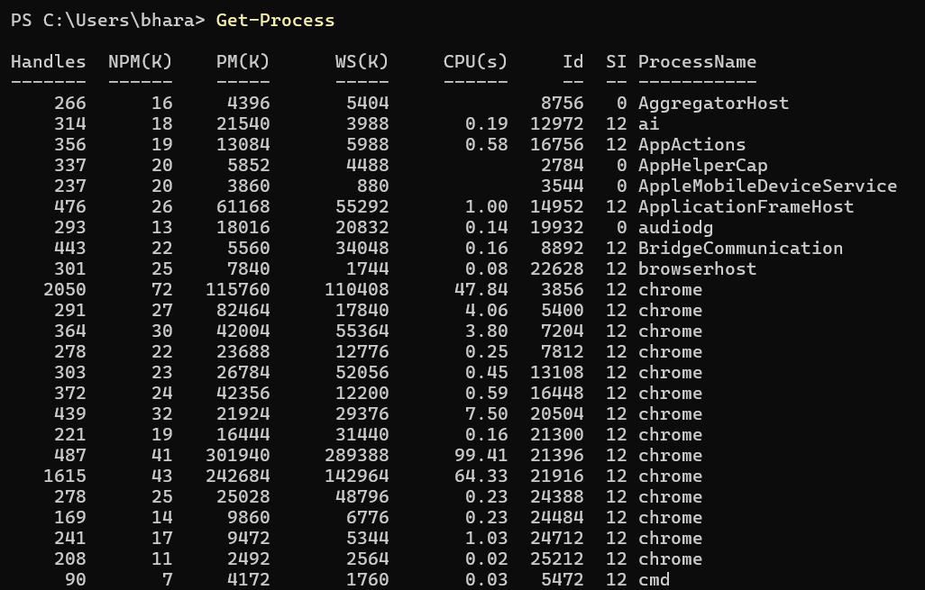
23. DISPLAY WINDOWS VERSION
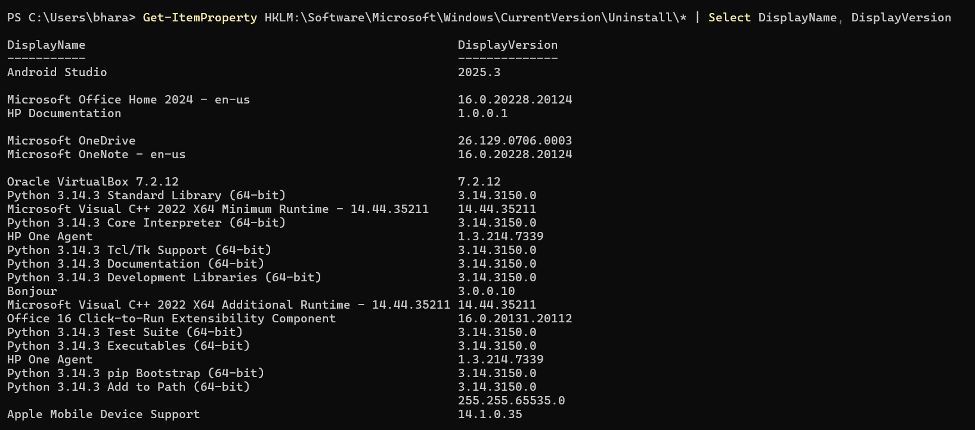
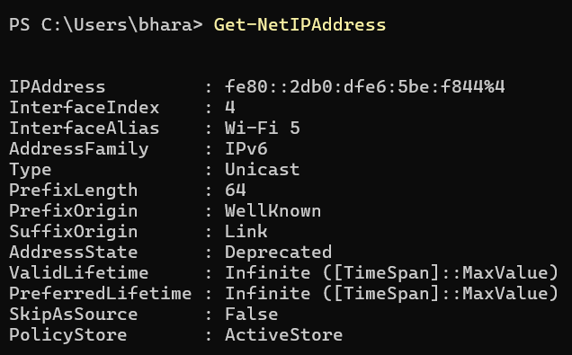
24. SHOW IP ADDRESS

25. DISPLAY DRIVE USAGE
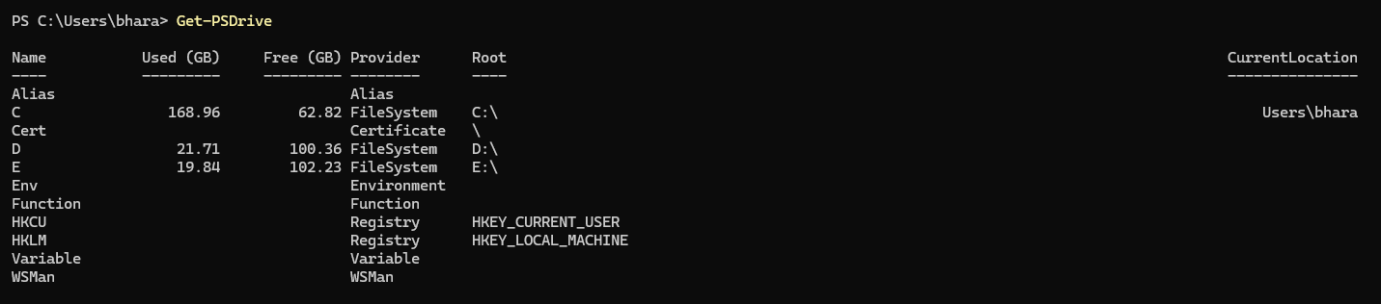
26. LIST LOCAL GROUPS
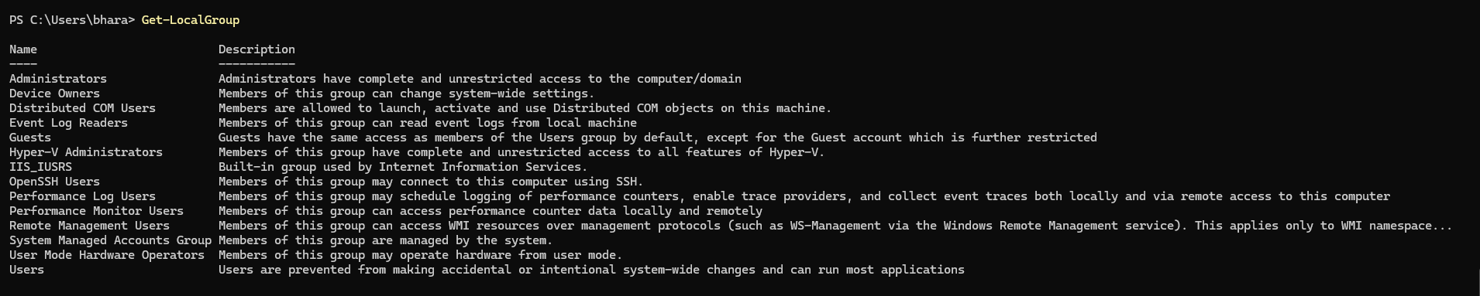
27. LIST USER ACCOUNTS
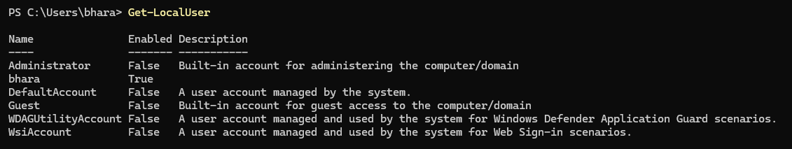
28. SHOW EXECUTION POLICY
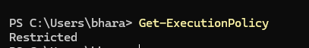
29. DISPLAY COMMAND HISTORY
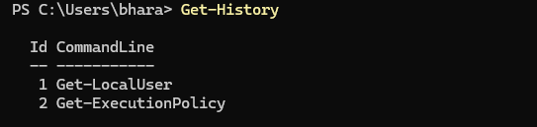

30. GET HELP FOR A COMMAND
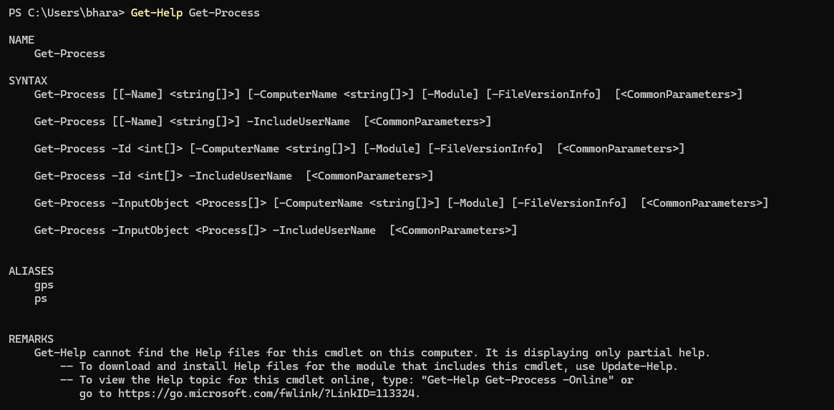
31. SHOW WINDOWS VERSION
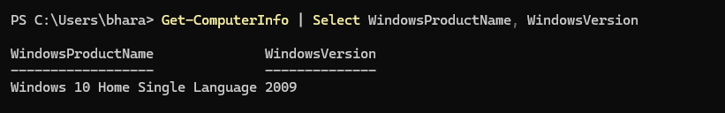
32. SHOW BIOS INFORMATION
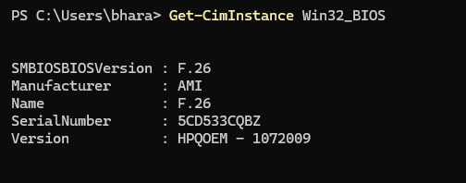
33. SHOW BIOS SERIAL NUMBER
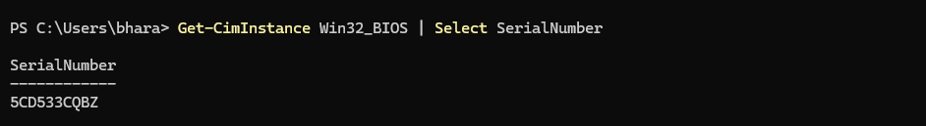

34. SHOW MOTHERBOARD DETAILS
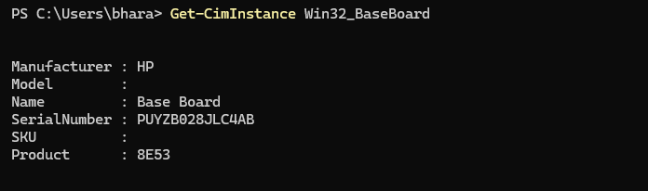
35. SHOW MOTHERBOARD SERIAL NUMBER
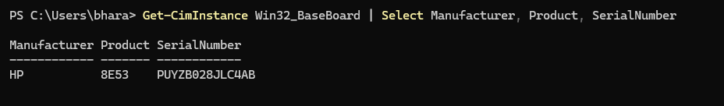
36. SHOW CPU DETAILS
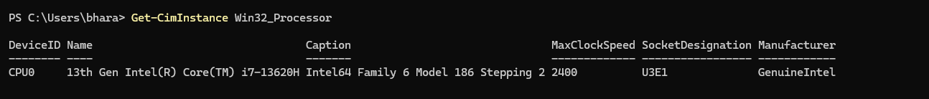
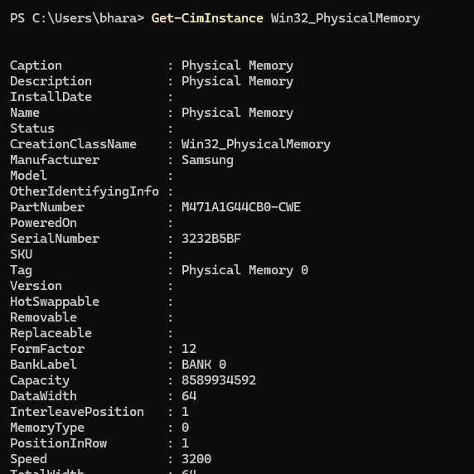
37. SHOW RAM DETAILS
38. SHOW RAM SERIAL NUMBER
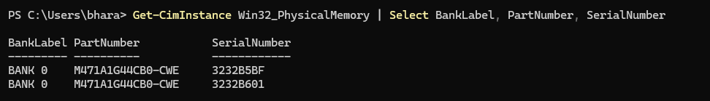
39. SHOW DISKS
40. SHOW DISK SERIAL NUMBER
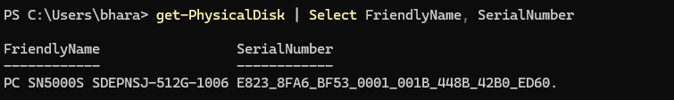
41. Show Disk Volumes
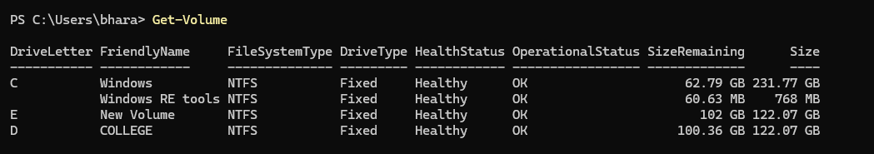
42. SHOW DRIVE USAGE
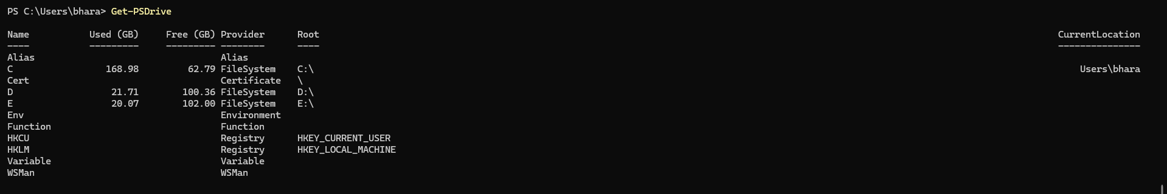
43. PING A HOST
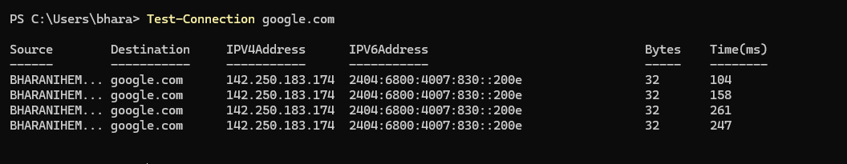
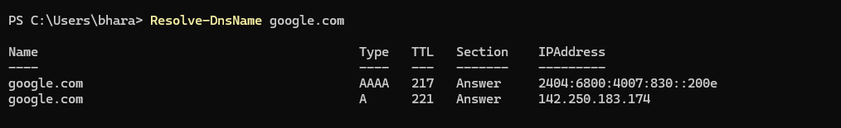
44. DNS LOOKUP
45. SHOW ROUTING TABLE
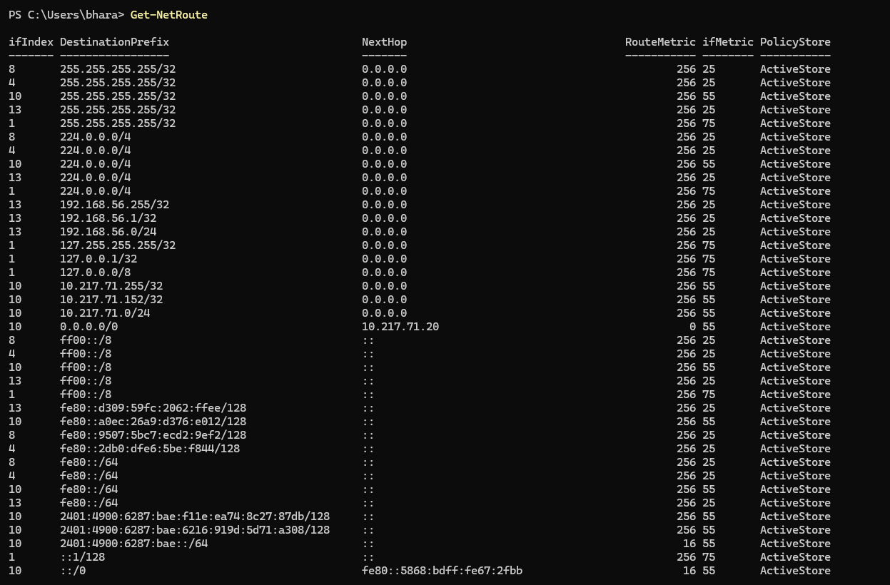
46. GENERATE A RANDOM NUMBER
47. MEASURE NUMBER OF FILES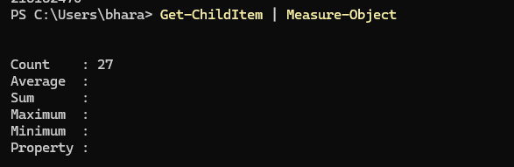

48. SHOW WINDOWS DEFENDER STATUS
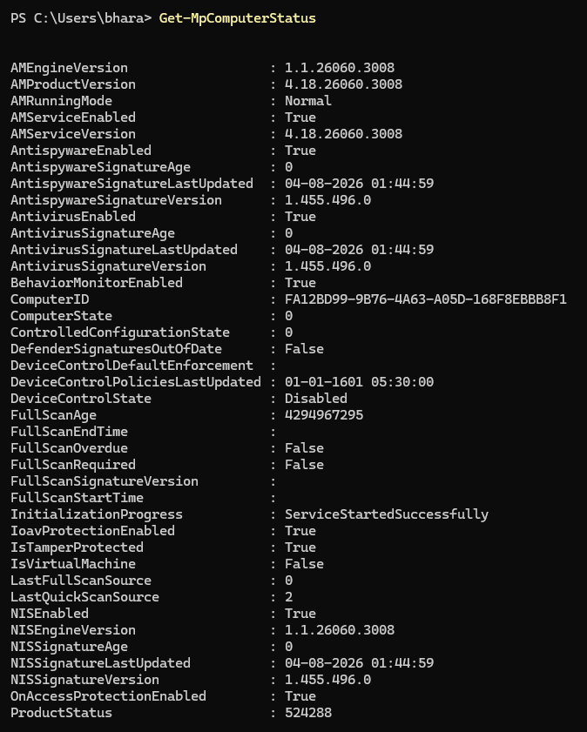

49. SHOW DISK PARTITIONS
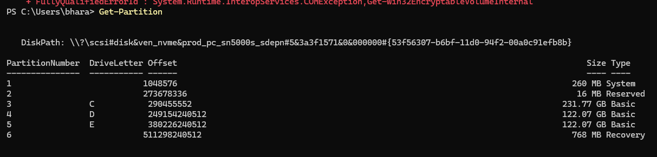
50. SHUT DOWN AFTER 1 MINUTE

NETSH
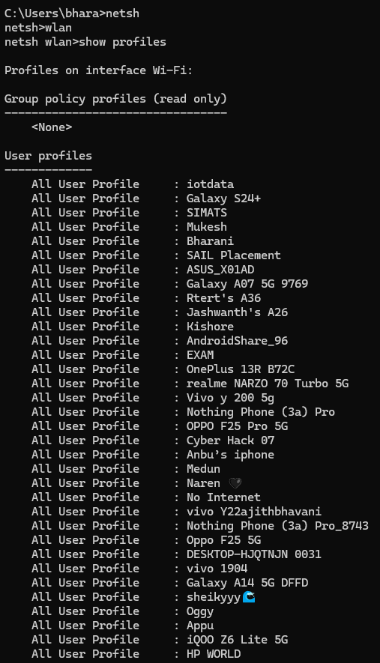
1. SHOW WIFI

2.SHOW WIFI PASSWORD

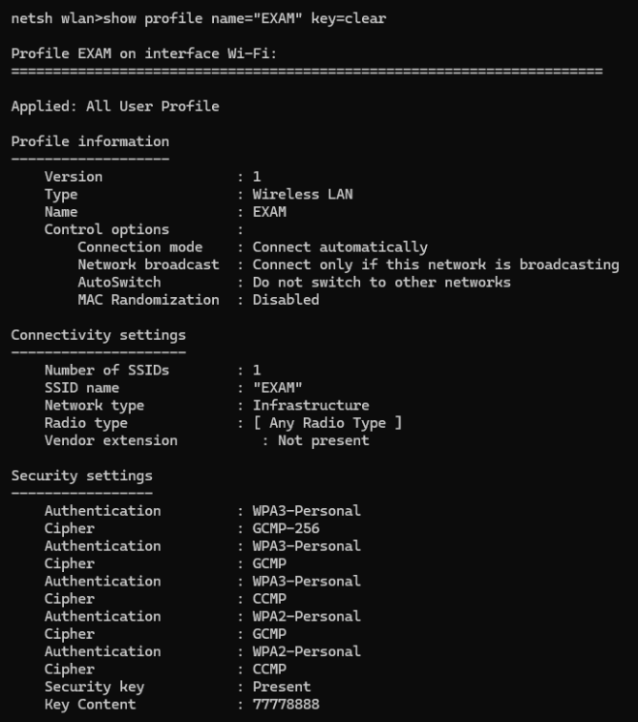
3.

